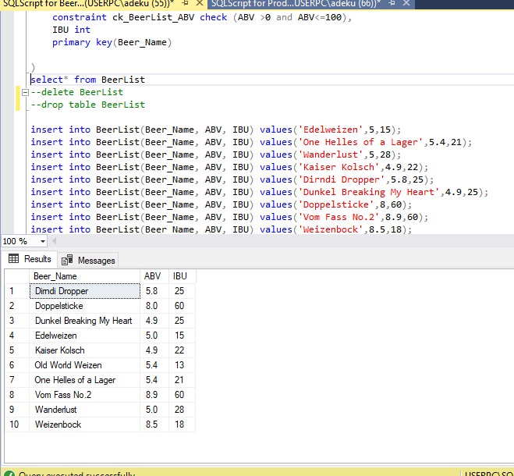

update BeerList

set Beer_Name='IPL'

where Beer_Name='Old World Weizen';

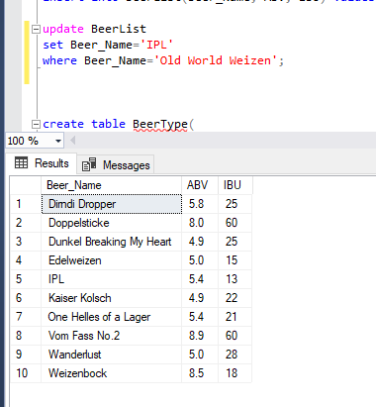

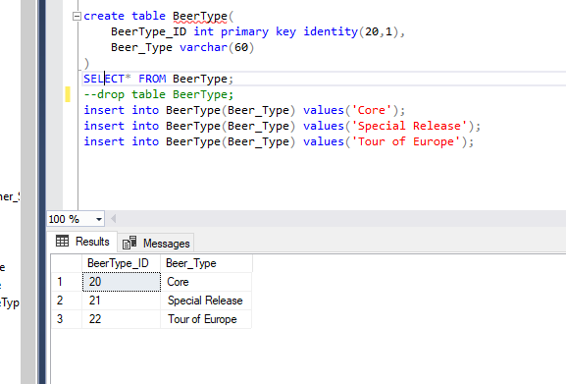

update BeerType

set Beer_Type='Very Special Release'

where Beer_Type='Special Release';

